**텀 프로젝트 발표자료**

**회원형 리조트 데이터베이스**

**산업시스템공학과**

**2017112508**

**최관호**

mysql -u root -p

create database myresort;

show databases;

use myresort;

*회원

create table member

(id char(4) not null, name varchar(20) not null, phone int not null, primary key(id));

Desc member;

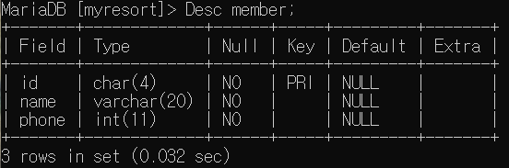

*회원 인스턴스

insert into member(id,name,phone) values

(“h001”, ”일관호”, 01000001111),

(”h002”, ”이관호”, 01000002222),

(”h003”, ”삼관호”, 01000003333),

(”h004”, ”사관호”, 01000004444),

(”h005”, ”오관호”, 01000005555),

(”h006”, ”육관호”, 01000006666);

select*from member;

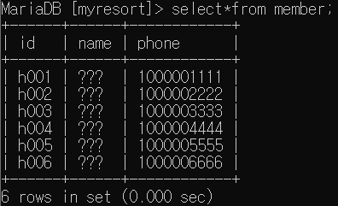

*직원

create table worker

(id char(4) not null, name varchar(20) not null, phone int not null, start date not null, career varchar(20) not null, primary key(id));

Desc worker;

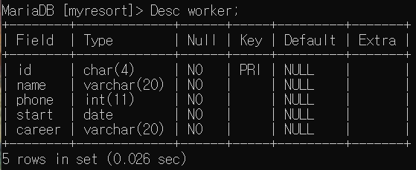

*직원 인스턴스

insert into worker values

(“w001”,”일수영”,01011111111,”2020-11-11”,”1개월”),

(“w002”,”이수영”,01022222222,”2020-12-12”,”2개월”);

update worker set career=”0개월” where career=”2개월”;

select*from worker;

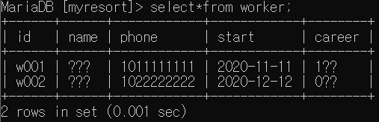

*매니저

create table manager

(id char(4) not null, name varchar(20) not null, phone int not null, start date not null, career varchar(20) not null, primary key(id));

Desc manager;

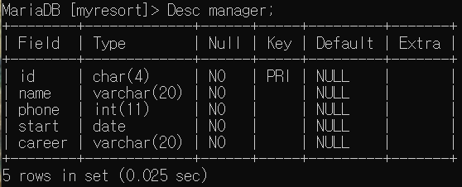

insert into manager values

(“m001”,”일민수”,01011110000,”2020-11-11”,”1개월”),

(“m002”,”이민수”,01022220000,”2020-12-12”,”0개월”);

Select*from manager;

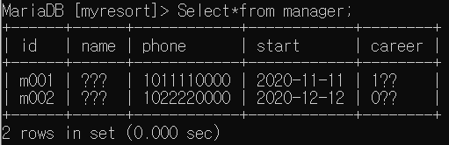

*객실

create table room

(id char(4) not null, class varchar(20) not null, cost int not null, primary key(id));

Desc room;

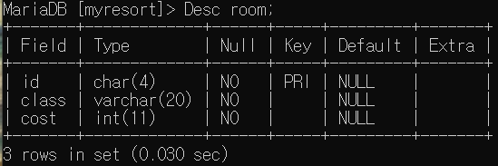

insert into room values

(“s001”, ”SUITE”, 100),

(”s002”, ”VIP”, 120);

select*from room;

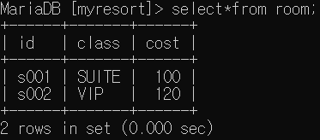

*직급

Create table rank

(id varchar(20) not null, name varchar(20) not null, worker_id char(4) not null, primary key(id), foreign key(worker_id) references worker(id));

Desc rank;

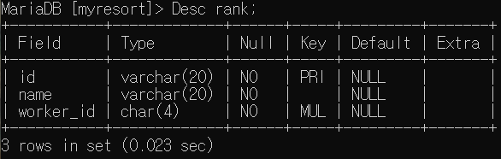

*회원 등록

create table member_register

(worker_id char(4) not null, member_id char(4) not null, date date not null, foreign key(worker_id) references worker(id), foreign key(member_id) references member(id));

Desc member_register;

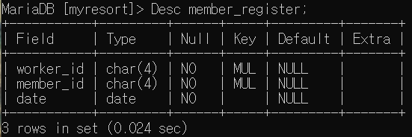

* 매니저 관리

create table training

(worker_id char(4) not null, manager_id char(4) not null, date date not null, foreign key(worker_id) references worker(id), foreign key(manager_id) references manager(id));

Desc training;

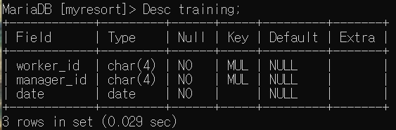

*예약기록

create table booking

(member_id char(4) not null, manager_id char(4) not null, room_id char(4) not null, date date not null, primary key(member_id), foreign key(member_id) references member(id), foreign key(manager_id) references manager(id), foreign key(room_id) references room(id));

Desc booking;

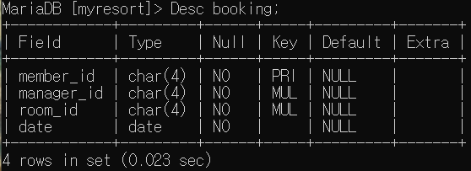

*이용기록

create table history

(member_id char(4) not null, room_id char(4) not null, date date not null, payment varchar(20) not null, primary key(room_id), foreign key(member_id) references member(id), foreign key(room_id) references room(id));

Desc history;

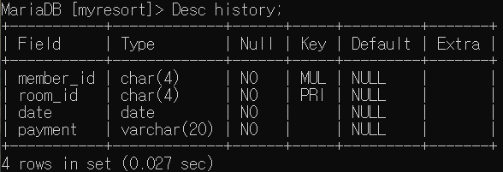

Insert into history

(select mb.id, rm.id, “2020-12-25”, “CARD” from member mb, room rm where mb.id=”h001” and rm.id=”s001”);

Insert into history

(select mb.id, rm.id, “2020-12-27”, “CARD” from member mb, room rm where mb.id=”h001” and rm.id=”s002”);

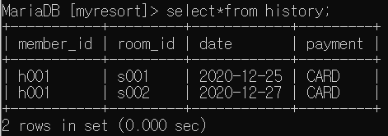

Select member_id, count(*) as Number_of_use From history group by member_id;

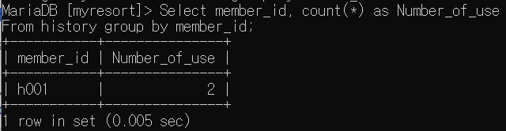

*객실 관리 기록

create table room_check

(room_id char(4) not null, worker_id char(4) not null, safestate varchar(20) not null, cleanstate varchar(20) not null, safedate date not null, cleandate date not null, primary key(room_id), foreign key(room_id) references room(id), foreign key(worker_id) references worker(id));

Desc room_check;

